Experience-Level Classification & Skill Analytics
for LinkedIn Job Postings
An end-to-end NLP pipeline comparing a logistic-regression baseline with a bidirectional LSTM, under ordinal-aware evaluation, statistical testing and SHAP-based model explainability.

Authors | Andrea Bardini and Filippo Maria Incecchi
Professor | Angela Locoro
Course | Artificial Intelligence
Programme | Analytics and Data Science for Economics and Management
University | Università degli Studi di Brescia
Dataset | LinkedIn Job Postings (2023–2024), ~119k postings (Kaggle)
Date | June 2026

Abstract
This project builds a complete natural-language-processing pipeline over roughly 119,000 LinkedIn job postings (2023–2024). It extracts a 172-skill taxonomy and analyses skill and salary demand, implements and honestly evaluates a skill-based job recommender, and predicts a posting's seniority level — Entry < Associate < Mid-Senior < Director < Executive — with a TF-IDF + logistic-regression baseline and a bidirectional LSTM. Because seniority is ordinal and heavily imbalanced (Executive is only 1.34% of the labelled data), the work emphasises methodology over raw accuracy: ordinal-aware metrics (MAE-in-levels and quadratic-weighted Cohen's kappa), square-root-dampened class weights, a title-leakage experiment, a McNemar significance test, and SHAP-based explainability. The bidirectional LSTM reaches macro-F1 0.713, accuracy 0.781 and QWK 0.773, beating the baseline on every metric by a statistically significant margin (McNemar χ² = 190.4, p ≈ 2.6 × 10⁻⁴³) while training in only a few minutes.

1. Introduction and Overall Idea
Online job markets encode a large amount of structured knowledge in unstructured text. A single LinkedIn posting names the role, lists required skills, hints at a salary band and states a required seniority level. The overall idea of this project is to turn that free text into structured, queryable intelligence and, in particular, to predict the seniority level of a posting directly from its wording.
The pipeline is organised around three connected goals:
Skill & market analytics: build a curated skill taxonomy, measure which skills are most in demand and how they shift across seniority, and quantify how salary varies by skill with explicit uncertainty.
Job recommendation: given a candidate profile, recommend the most relevant postings using skill-vector similarity, and evaluate the recommender honestly.
Seniority classification — the core AI task, a five-class, ordinal text-classification problem solved first with a classical baseline and then with a deep recurrent model, compared rigorously.
Throughout, the design choices are driven by two realities of the data: seniority levels are ordered (an Entry-vs-Associate error is milder than an Entry-vs-Executive error), and the classes are severely imbalanced. These two facts motivate almost every methodological decision that follows.

2. Dataset and Data Elaboration

2.1 Source, cleaning and the two text fields
The corpus is the public LinkedIn Job Postings (2023–2024) dataset (123,849 raw rows, ~970 MB). After cleaning — lower-casing, stripping HTML, URLs and boilerplate, normalising salaries to a yearly figure, and removing 4,836 duplicate rows plus 44 further rows (37 with unrealistic salaries and 7 missing critical fields) — 118,969 postings remain. For every posting two parallel text fields are kept: full_text (title + description + skills section) and desc_text (description + skills only, without the title). Keeping the title out of the second field is deliberate: it later lets us measure how much of the model's accuracy comes from the title literally containing the answer — the leakage experiment in Section 3.

2.2 Class distribution — the central challenge
The target, formatted_experience_level, is strongly imbalanced. Mid-Senior (44.9%, 39,787 rows) and Entry (39.1%, 34,634) together make up about 84% of the labelled data, while Associate is 10.7% (9,449), Director 4.0% (3,593) and Executive just 1.34% (1,184 rows). About a quarter of all postings (≈30,300 rows) carry no usable seniority label (Unknown or Internship); these are excluded from the supervised task and used only by the recommender, leaving 88,647 labelled postings for classification. This long-tailed distribution — especially the tiny Executive class — is the single most important driver of the modelling strategy.

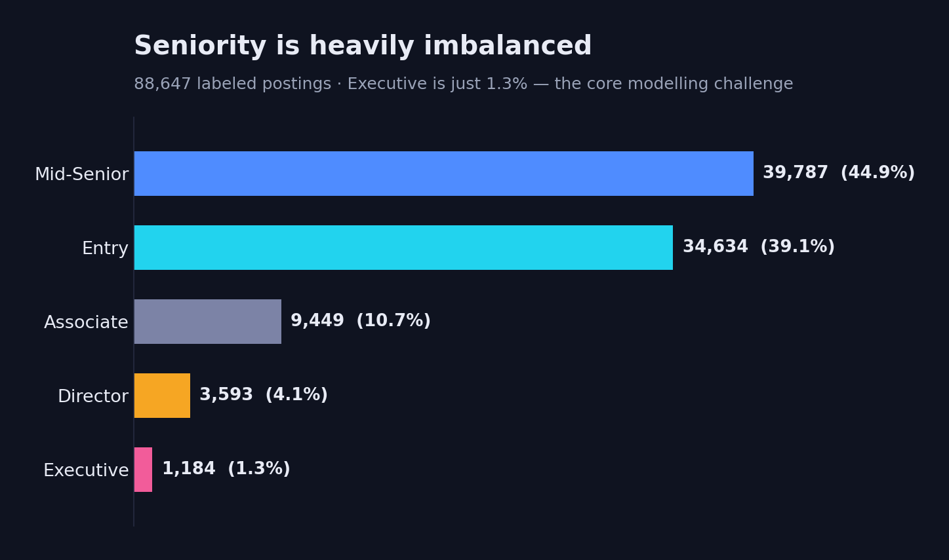

2.3 Skill taxonomy and demand
A hand-curated taxonomy of 172 skills across 11 categories (Programming, Data & Analytics, Machine Learning & AI, Cloud & DevOps, Software Development, Business & Management, Marketing & Sales, Finance & Accounting, Soft Skills, Education and Experience signals) is matched against each posting with pre-compiled regular expressions. Edge cases are handled explicitly — for example the single-letter language 'r' is matched only through contextual forms such as 'r programming', 'rstudio' or 'programming in r' to avoid thousands of false positives. On average a posting matches 3.5 skills and 80.4% of postings match at least one. Demand is dominated by soft skills and credentials rather than tools: communication (28.0%), bachelor's degree (27.1%), leadership (23.8%) and problem-solving (16.2%) lead, while the top technical skill is Excel (14.5%), followed by SQL (4.3%) and Python (3.9%). The comparatively low technical percentages are expected for a corpus spanning every industry, not an extraction failure.
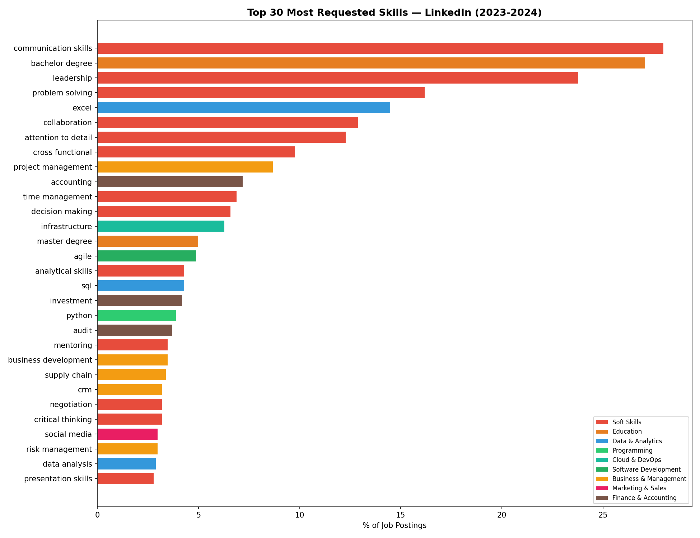
Figure 1. Top-30 most-requested skills, coloured by taxonomy category. Soft skills and credentials dominate a cross-industry corpus.
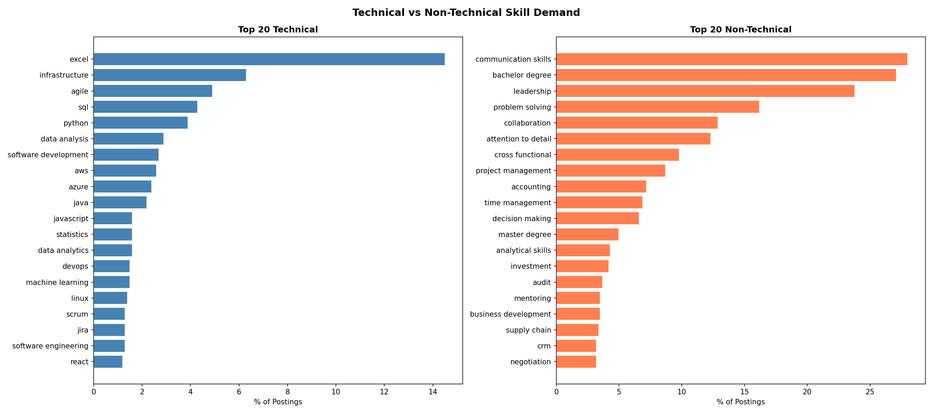
Figure 2. Technical vs non-technical skill demand. Even the leading technical tools trail the most common soft skills and credentials.
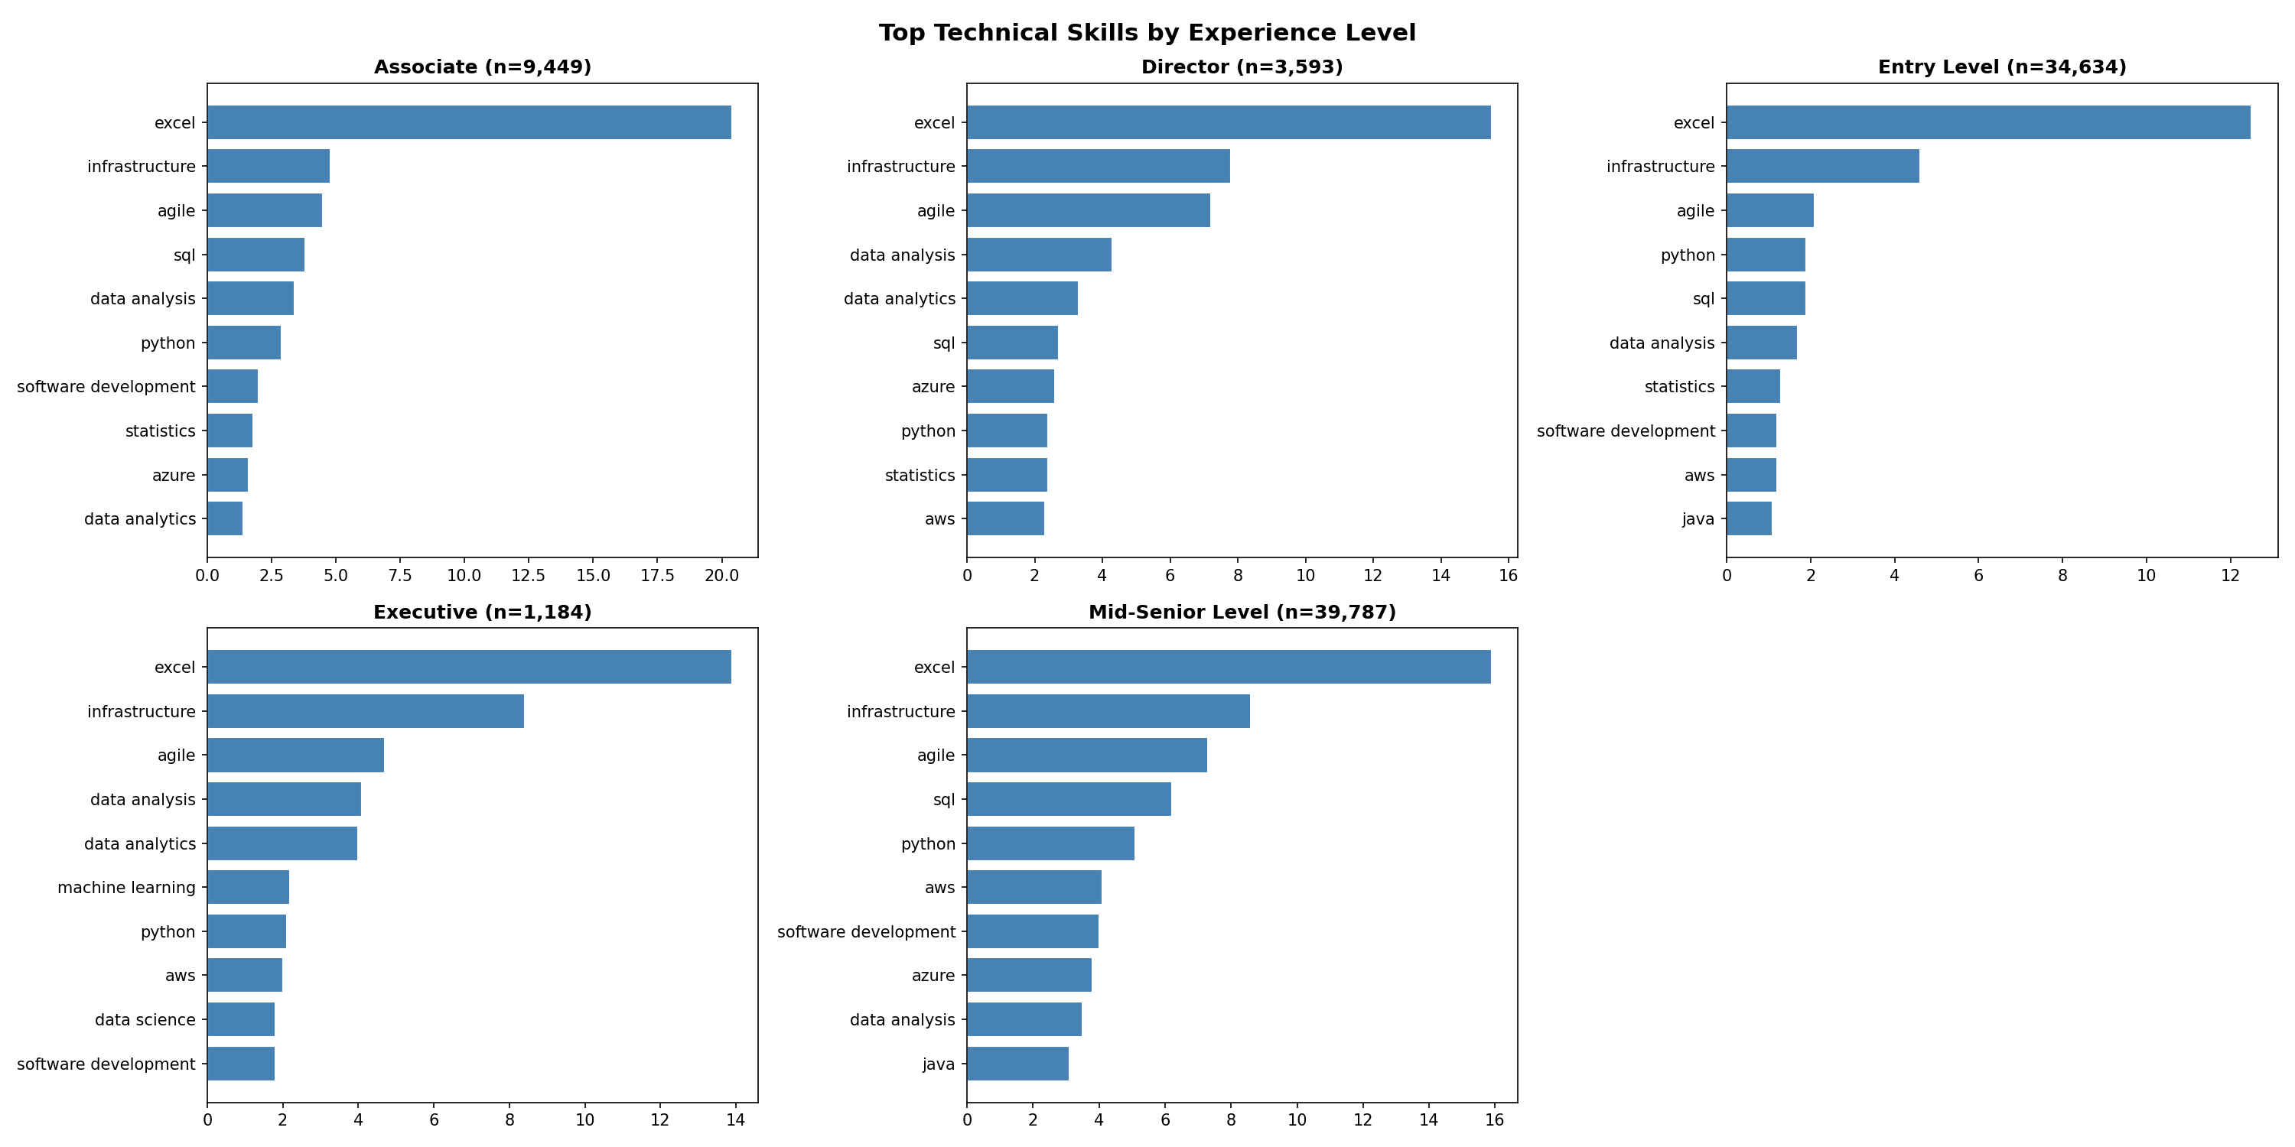
Figure 3. Top technical skills by experience level. Hands-on tools concentrate at Entry/Mid-Senior; per-level sample sizes shrink sharply for Director and Executive, so those bars are indicative.

2.4 Salary analysis with uncertainty
Only 5.1% of postings carry a salary, so the salary study runs on a much smaller USD subset (6,056 postings). Crucially, each per-skill median is reported with a bootstrap 95% confidence interval (2,000 resamples), so noisy rankings become visible rather than misleading. The overall USD median is $47,954 (mean $64,946), pulled down by the many non-technical and part-time roles. High-paying skills such as Java ($145.6k) top the raw ranking, but Java rests on only n = 41 postings with a wide CI ($124.8k–$156k): its first place is mostly sampling noise. The trustworthy figures are the high-n, narrow-CI skills — Excel ($52k–$56.2k, n = 760), Python ($120k–$132.5k, n = 86) and SQL ($110k–$129.9k, n = 119). Median pay rises with seniority (Entry $42.6k, Associate $56.2k, Mid-Senior $66.6k, Director $140k) with one instructive caveat: Executive's median ($120k, n = 25) sits below Director's despite a higher mean ($151k) — a small-sample artifact, not a real inversion.
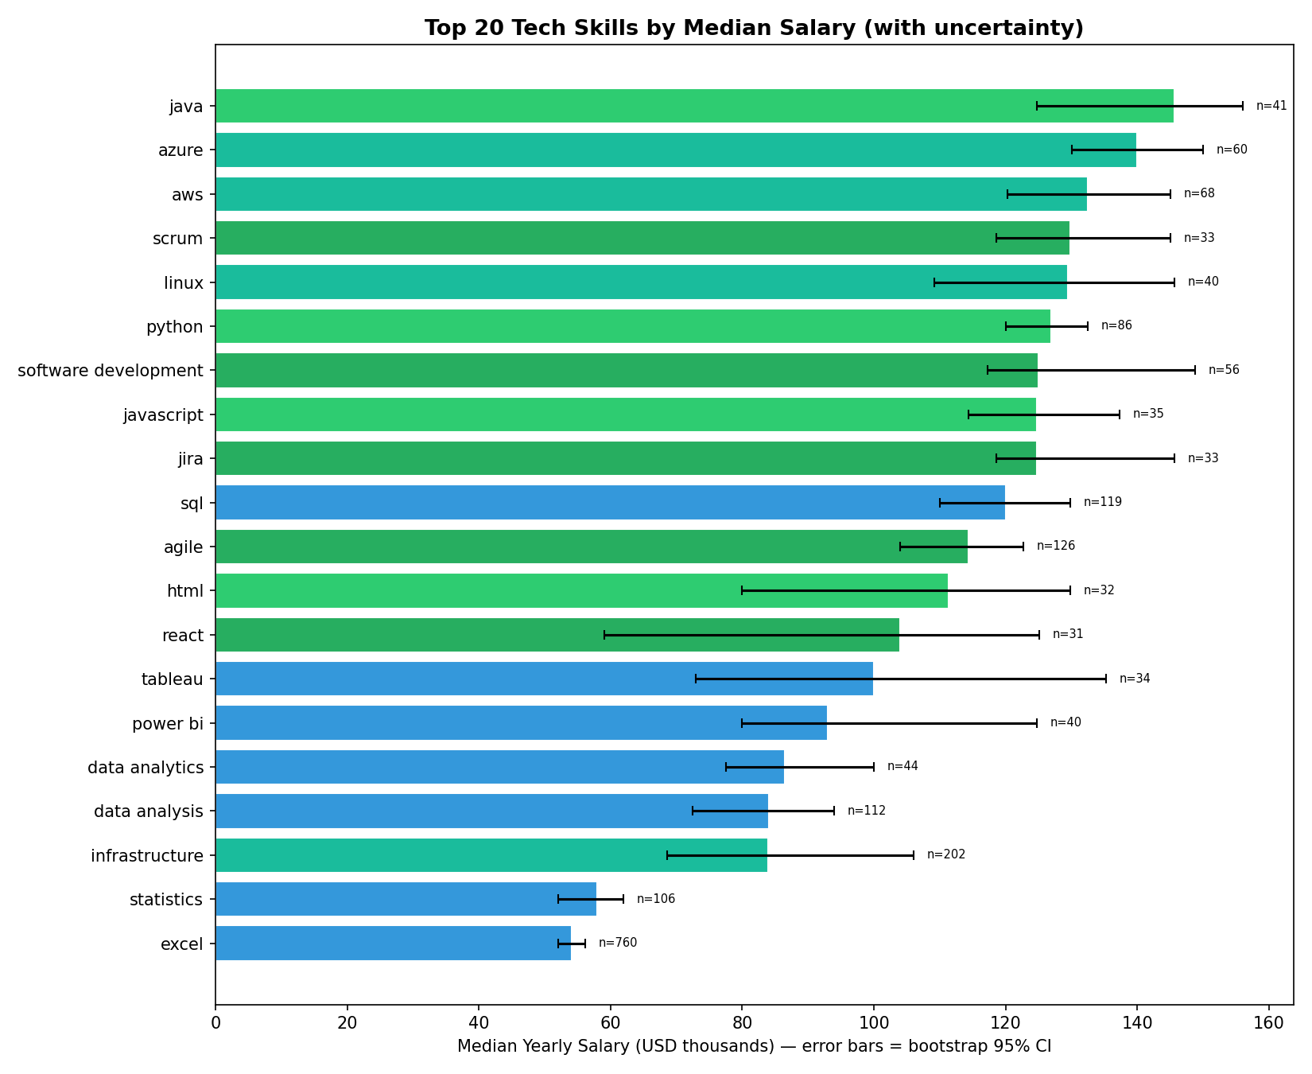
Figure 4. Median USD salary by technical skill with bootstrap 95% confidence intervals; interval width flags which rankings are trustworthy (note the small-n labels).

3. Methodology — Design and Rationale
The modelling philosophy is to start from a strong, transparent baseline, make the evaluation match the structure of the problem, and only then introduce a deep model — so that any gain is measured fairly and is attributable to the model rather than to the metric.

3.1 Ordinal-aware evaluation
Because the five levels are ordered, plain accuracy and macro-F1 are insufficient: they penalise an off-by-one confusion exactly as harshly as an extreme one. Two ordinal metrics are added alongside macro-F1 and accuracy: MAE-in-levels (the mean absolute distance between true and predicted rank) and quadratic-weighted Cohen's kappa (QWK), the standard ordinal-agreement measure. A subtle but important implementation detail is that scikit-learn's label encoder sorts classes alphabetically (Associate, Director, Entry, Executive, Mid-Senior), which is not the seniority order; an explicit rank map (Entry 0 → Executive 4) is therefore applied before computing the ordinal metrics.

3.2 Baselines and the title-leakage experiment
The baseline is a TF-IDF vectoriser (50,000 features, uni- and bi-grams, sublinear term frequency, minimum document frequency 3) feeding a multinomial logistic regression with balanced class weights. It is trained twice — once on full_text and once on desc_text — to isolate the contribution of the title. The title adds +0.043 macro-F1 (0.671 vs 0.628). Inspecting the largest coefficients shows why: titles literally contain the label ('vp', 'vice president', 'chief' → Executive; 'director' → Director; 'manager', 'senior', 'sr' → Mid-Senior). The leakage is modest but real for the linear model, which is why the deep model is also trained description-only; its description-only row reveals a markedly larger title effect (+0.112 F1, Section 4).

3.3 Handling imbalance: square-root-dampened class weights
Fully balanced class weights give Executive a weight near 15, which dominates the loss and makes the model over-predict Executive everywhere. Instead, the balanced weights are square-root dampened (15 → ≈3.9): the minority boost is preserved but tempered, trading a little Executive recall for substantially better precision. The weights are computed on the training (fit) split only and applied during fitting.

3.4 The bidirectional LSTM
Text is tokenised to a 30,000-word vocabulary and padded/truncated to 200 tokens. The network is a compact recurrent classifier (3.95M trainable parameters, ~15 MB):
Layer | Configuration
Embedding | 30,000 × 128 (sequence length 200, explicit Input layer) — 3,840,000 params
SpatialDropout1D | rate 0.3 (drops whole embedding channels)
Bidirectional LSTM | 64 units / direction, dropout 0.3 (cuDNN kernel) — 98,816 params
Dense | 64 units, ReLU — 8,256 params
Dropout | rate 0.3
Dense (output) | 5 units, softmax — 325 params
Loss / optimiser | sparse categorical cross-entropy / Adam
Training | batch 64, stratified 10% validation, ≤10 epochs, early stopping on val-loss
Table 1. Bidirectional-LSTM architecture and training configuration.
A key design choice is using ordinary dropout rather than recurrent dropout inside the LSTM. Recurrent dropout disables the optimised cuDNN GPU kernel and forces a slow generic implementation; removing it cuts training from roughly 85 minutes to a few minutes (about 20–40 seconds per epoch) with no loss of validation accuracy. Regularisation is instead supplied by SpatialDropout1D and the dense dropout layer. A stratified 10% validation set is carved out of the training data so the rare Executive class is represented during validation, and early stopping on validation loss (patience 2, best weights restored) halts training once the model begins to overfit. The same network is trained on both text fields, yielding the title and description-only rows of Table 2.

3.5 Job recommender
The recommender represents each posting as a skill vector and ranks postings by cosine similarity to a query profile, comparing a binary skill encoding against a TF-IDF weighting. Because about a quarter of postings have an Unknown level, precision is computed only over recommendations whose level is known (P@10-known), and the Unknown-recommendation rate is reported separately so a method cannot 'win' simply by hiding its mistakes in the unlabeled set. Skill coverage (overlap between the query skills and the recommended postings' skills) is also reported.
Method | P@10 (known) | Unknown rate | Skill coverage
Binary | 0.719 | 0.275 | 0.645
TF-IDF | 0.753 | 0.450 | 0.661
Table 2 (recommender). Averages over four synthetic profiles. TF-IDF edges binary on P@10-known but only by surfacing more Unknown postings (which leave the precision denominator), so binary is the more reliable default.

On average TF-IDF edges binary on P@10-known (0.753 vs 0.719), but this is partly an artifact: TF-IDF also surfaces more Unknown-level postings (unknown rate 0.45 vs 0.27), which are dropped from the precision denominator, so it is scored on a smaller, easier set. Binary is the more reliable choice — lower Unknown-rate and a decisive win on the Junior Data Scientist profile (0.714 vs 0.429) — because TF-IDF down-weights exactly the frequent skills ('python', 'leadership') that define these profiles. Per-profile results vary widely (TF-IDF nails the VP profile at 1.00; binary wins Marketing), so neither method dominates everywhere.

4. Evaluation

4.1 Model comparison and ordinal metrics
On the held-out, stratified 20% test set (17,730 labelled postings), the BiLSTM leads on every metric. The ordinal metrics matter most: a lower MAE-in-levels and higher QWK mean the model's mistakes land closer to the true seniority, not merely less often.
Model | Macro-F1 | Accuracy | MAE-levels ↓ | QWK ↑
LogReg (title + description) | 0.671 | 0.734 | 0.393 | 0.702
LogReg (description-only) | 0.628 | 0.711 | 0.429 | 0.674
BiLSTM (title + description) | 0.713 | 0.781 | 0.310 | 0.773
BiLSTM (description-only) | 0.602 | 0.707 | 0.451 | 0.631
Table 3. Final model comparison on the test set (best model shaded). Arrows show the desired direction.
The per-class breakdown for the BiLSTM (title + description) explains where the macro-F1 of 0.71 comes from — and where it does not.
Class | Precision | Recall | F1 | Support
Entry Level | 0.84 | 0.82 | 0.83 | 6,927
Associate | 0.47 | 0.53 | 0.50 | 1,890
Mid-Senior Level | 0.83 | 0.80 | 0.82 | 7,958
Director | 0.70 | 0.78 | 0.74 | 718
Executive | 0.60 | 0.78 | 0.68 | 237
Macro average | 0.69 | 0.74 | 0.71 | 17,730
Table 4. Per-class performance of the BiLSTM (title + description) on the test set, in seniority order.
The model is strongest on the well-populated, lexically distinct levels (Entry F1 0.83, Mid-Senior 0.82) and solid on Director (0.74). The dampened weights deliberately lift Executive to recall 0.78 at the cost of precision 0.60 (F1 0.68) — the intended trade, casting a wide net for the rare top class. Associate is the clear weak point (F1 0.50): as a middle ordinal class with no distinctive vocabulary, it is routinely absorbed by its Entry and Mid-Senior neighbours — visible in the confusion matrix below, where 18% of Associates leak to Entry and 27% to Mid-Senior. Training the same BiLSTM on the description only drops macro-F1 to 0.602, a +0.112 fall: the deep model leans on the title far more than the linear baseline (+0.042), an honest caveat the two-field design makes visible.
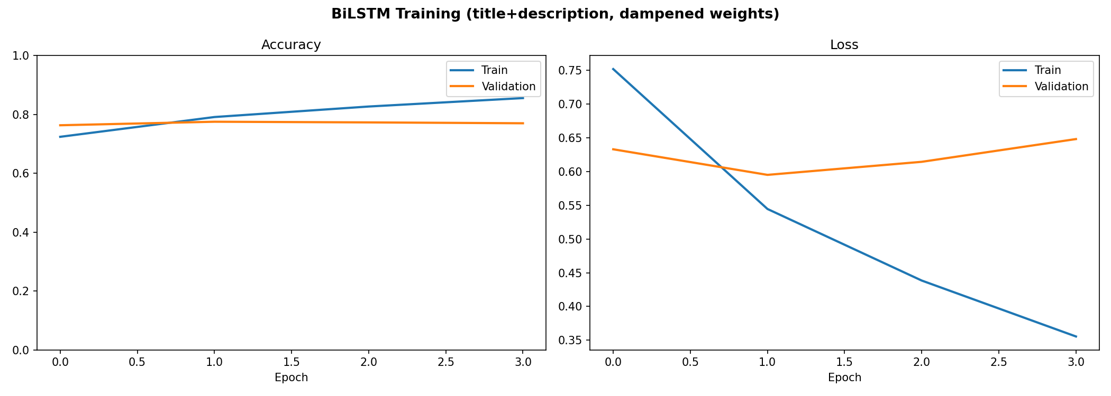
Figure 5. Training curves (title + description). Validation accuracy plateaus near 0.78 while training accuracy keeps rising and validation loss turns upward — mild overfitting that early stopping cuts off at the best epoch (epoch 2, val-loss 0.595).
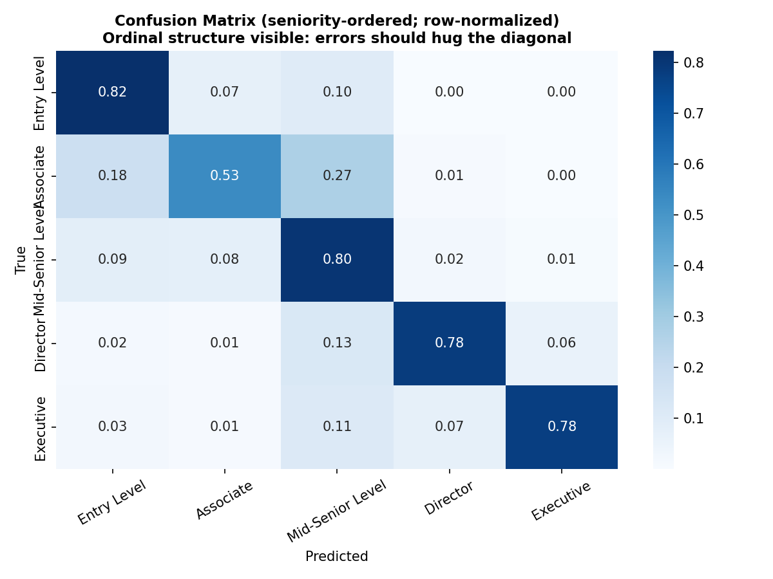
Figure 6. Row-normalised confusion matrix in seniority order. The mass concentrated on and adjacent to the diagonal confirms the errors are ordinally well-behaved.

4.2 Statistical significance
A win on point estimates is not automatically meaningful, so the BiLSTM and the logistic baseline are compared with McNemar's test on their paired test-set predictions. Of the 17,730 test postings, both models are correct on 11,592 and both wrong on 2,458; among the discordant cases the BiLSTM is correct on 2,259 postings the baseline misses, against only 1,421 the other way — yielding χ² = 190.4 and p ≈ 2.6 × 10⁻⁴³. The accuracy advantage is therefore statistically overwhelming and, given the few-minute training cost, cheap to obtain.

4.3 Explainability: SHAP-based token importance
Explainability is approached with SHAP (SHapley Additive exPlanations). SHAP assigns each feature its Shapley value — the feature's average marginal contribution to the prediction taken over many subsets (coalitions) of the other features — which gives attributions with desirable theoretical guarantees (local accuracy/additivity, missingness and consistency). The deployed pipeline (Keras tokenizer → pad → BiLSTM) is wrapped in a black-box probability function and explained with SHAP's Partition explainer and a Text masker that removes whole words and re-scores. To ensure every class is represented — including the rare leadership levels — the diagnostic samples 60 documents stratified across predicted classes (12 each), caps each text at 200 words, and keeps only tokens that recur in at least two documents of a class.
Occlusion — zeroing a single token and measuring the drop in the predicted-class probability — is the simplest member of this same family: it measures one marginal effect rather than averaging over coalitions, so it can be read as a fast, one-coalition approximation of a Shapley value. SHAP is more faithful at higher cost (here ~9 minutes for 60 documents): it distributes importance more fairly across correlated cues, so overlapping signals (e.g. 'senior' + 'manager') share credit rather than each scoring the full probability drop.
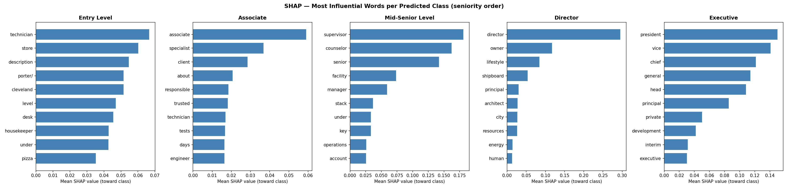
Figure 7. SHAP token importance — the ten most influential words per predicted class (panels in seniority order: Entry, Associate, Mid-Senior, Director, Executive). The stratified 60-document sample populates all five levels.
The recovered drivers are intuitive: Entry is carried by concrete role and industry words (technician, store, desk, housekeeper, porter), Associate by role and staffing nouns (associate, specialist, client, engineer, technician), Mid-Senior by supervisory cues (supervisor, senior, manager, operations, account), Director by leadership and ownership terms (director, owner, principal, architect, head), and Executive by top-leadership tokens (president, vice, chief, general, head, executive). That the model keys on broadly the words a human would expect is reassuring evidence that it has learned a meaningful representation rather than a spurious shortcut; the few corpus-specific tokens that also surface (place and company names such as 'cleveland' or 'shipboard') are a reminder that SHAP reflects the data as much as the concept.

4.4 Ethical considerations
- Decision-support, not automation. A model at ~78% accuracy must not gate candidates automatically. Its appropriate role is to assist and triage, with a human making the final call; deploying it as an automatic filter would risk automation bias, where users over-trust a confident-looking output.
- Unequal error rates across groups. The model is markedly weaker on some classes (Associate F1 0.50) than others (Entry 0.83). Any downstream use would systematically disadvantage the role types it predicts poorly, an equity concern that aggregate accuracy hides.
- Representativeness. The data are LinkedIn postings from 2023–2024, skewed towards English-language, white-collar and US roles (salaries are in USD). Conclusions and any model trained here do not transfer uncritically to other labour markets or languages.
- Proxy bias in free text. Job descriptions can carry gendered or otherwise biased phrasing; a text model may latch onto such language as a proxy. This was not audited here and would require a fairness analysis before any real use.
- Transparency as a safeguard. The SHAP explainability layer is itself an ethical tool: per-prediction rationales support contestability and align with the spirit of the GDPR provisions on automated decision-making.
- Honest reporting. Bootstrap confidence intervals on salaries and a leakage-aware recommender metric are deliberate guards against over-claiming — an ethic of not presenting noisy numbers as settled facts.

5. Limitations and Future Work
- Class imbalance remains the core difficulty. Associate is under-predicted, suggesting the five-way split is finer than the data fully support for the middle of the scale.
- Title leakage is real — small for the linear baseline (+0.04 F1) but markedly larger for the BiLSTM (+0.11 F1); it is kept transparent by reporting both title-inclusive and description-only results.
- The recommender lacks ground-truth relevance labels; P@10 is a proxy. A curated relevance set would make the evaluation rigorous.
- Next steps: (1) add a frozen sentence-embedding + logistic-regression model to complete the classical → recurrent → transformer spectrum; (2) build a semantic recommender on those embeddings to capture synonyms the taxonomy misses; (3) test merging Director + Executive into a single 'Senior Leadership' class to relieve the extreme imbalance; and (4) run full KernelSHAP/DeepSHAP and a fairness audit before any deployment.

6. Conclusion
The project delivers a complete, reproducible NLP pipeline that goes well beyond a single accuracy number. By matching the evaluation to the ordinal, imbalanced structure of the problem, testing the deep model against a strong baseline for statistical significance, and explaining its predictions with SHAP, it shows that a compact bidirectional LSTM offers a real and significant improvement over logistic regression (macro-F1 0.713 vs 0.671; QWK 0.773 vs 0.702; McNemar p ≈ 10⁻⁴³) while remaining cheap to train. Equally important, the work is honest about its weak spots — the Associate class and the title leakage that the deep model amplifies — and frames the result responsibly for any decision-support use.

References
[1] Lundberg, S. M. & Lee, S.-I. (2017). A Unified Approach to Interpreting Model Predictions (SHAP). Advances in Neural Information Processing Systems 30.
[2] Shapley, L. S. (1953). A Value for n-Person Games. Contributions to the Theory of Games II.
[3] Cohen, J. (1968). Weighted kappa: nominal scale agreement with provision for scaled disagreement. Psychological Bulletin.
[4] McNemar, Q. (1947). Note on the sampling error of the difference between correlated proportions. Psychometrika.
[5] Hochreiter, S. & Schmidhuber, J. (1997). Long Short-Term Memory. Neural Computation.
[6] Pedregosa et al. (2011). Scikit-learn: Machine Learning in Python. JMLR 12. / Abadi et al. (2016). TensorFlow.
[7] LinkedIn Job Postings (2023–2024) dataset, Kaggle.

